

**CSE370: Database Systems**

**Project Report**

**Project Title: Student Management System**

| **Group Name:** Delta**, CSE370 Lab Section:** 06**, Summer 2023** | | |
| --- | --- | --- |
| **ID** | **Name** | **Contribution** |
| 20101618 | Israt Jahan Ayshi | EER, Schema Diagram, Frontend, Backend, Report |
| 20101021 | Ms Rodsy Tahmid | EER, Schema Diagram, Frontend, Backend, Report |
| 20201027 | Sabikun Nahar | EER, Schema Diagram, Frontend, Backend, Report |

**Table of Contents**

| **Section**  **No** | **Content** | **Page No** |
| --- | --- | --- |
| 1 | Introduction | 3 |
| 2 | Project Features | 4 |
| 3 | ER/EER Diagram | 5 |
| 4 | Schema Diagram | 6 |
| 5 | Frontend Development | 7 |
| 6 | Backend Development | 13 |
| 7 | Conclusion | 22 |
| 8 | References | 22 |

**Introduction**

The Student Management System Project is a comprehensive system made to manage tasks associated with students in a learning environment effectively. This project combines the strength of SQL for database management, HTML, CSS, Bootstrap for responsive front-end design, PHP for backend logic, and JavaScript for dynamic user interactions. This system's primary goal is to improve communication between students, instructors, staff members, and administrative personnel while streamlining managerial procedures.

Front-end technologies include HTML5, CSS, Bootstrap, and JavaScript. PHP for back-end server-side scripting. MySQL is a database used for storing and retrieving data. JavaScript interactivity for dynamic features and improved user experience.

The advantages are effectiveness, accuracy, user-friendliness, and data analysis, Firstly, By automating manual administrative processes, the system saves time and effort.

Second of all, using computers to manage data decreases the chance of human error while keeping records. Users can access the system from any location that has an internet connection. Last but not least, everyone can easily navigate and engage with the system because of its intuitive interface. To make well-informed decisions, educators and administrators can examine data on student performance.

Using PHP, SQL, Bootstrap, and JavaScript, the Student Management System project provides educational institutions with a solid way to manage student-related duties efficiently, improve communication, and increase overall administrative effectiveness.

**Project Features**

The proposed Student Management System is a small-scale database management system website project for managing user data with some other key features, such as:

* **Homepage** 
  + Login System
  + Admission form
  + Noticeboard
* **Admin Dashboard**
  + Admission
  + Add student
  + Update Student
  + View student
  + Add teacher
  + View teacher
  + Add staff
  + View staff
  + Delete students, teachers, and staff
  + Assign courses
* **Student Dashboard** 
  + Update Profile
  + My courses
  + Payment
  + Post complaints
* **Teacher Dashboard**
  + Update Profile
  + Add courses
  + View courses
* **Staff Dashboard**
  + Update Profile
  + Post Notice
  + View complaints
  + Resolve complaints
  + Create payment
  + See payment status
* Logout

**ER/EER Diagram**

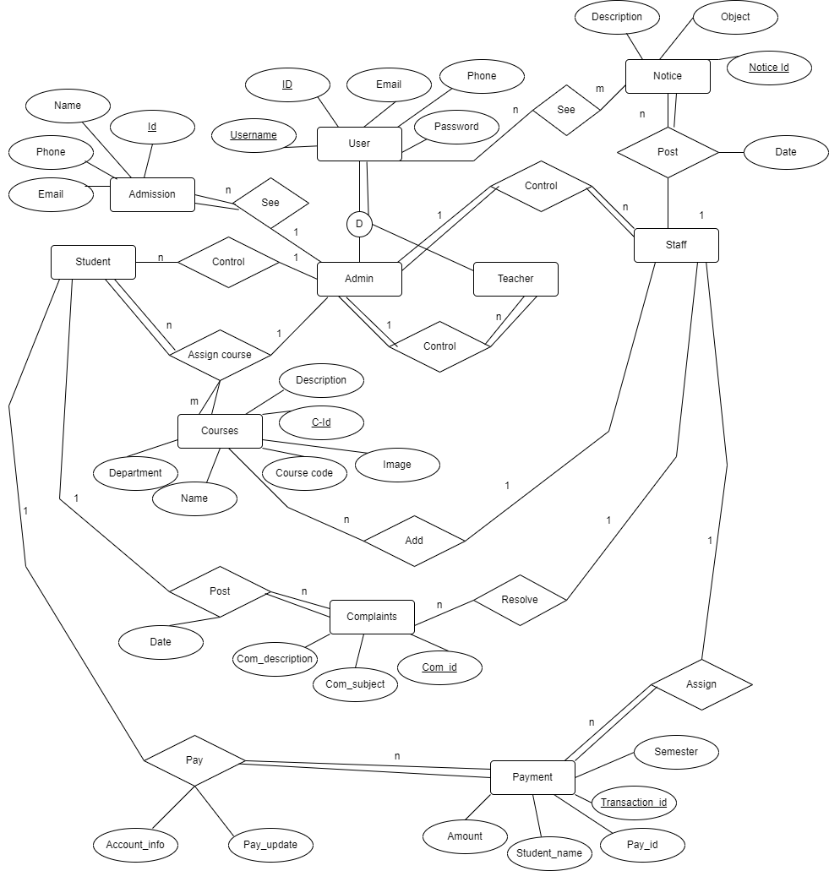

**Schema Diagram**

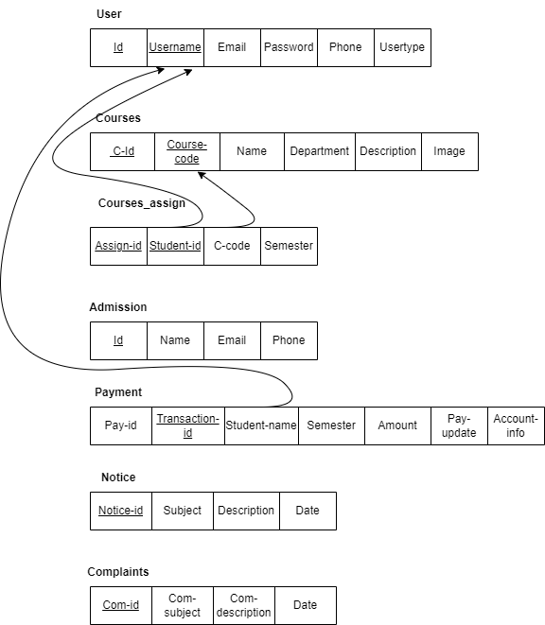

**Frontend Development**

**Contribution of ID: 20101618, Name: Israt Jahan Ayshi**

**Homepage:** The homepage, or index page, was designed using HTML, CSS, JavaScript, some PHP, and Bootstrap codes. In the navigation bar, there are four options, such as home, admission, noticeboard, and login button. In addition, the homepage contains an admission form that takes input from applicants, who can use the apply button to submit an application. The nav bar, application form, main image, and everything else were styled using CSS, and the buttons were styled using the Bootstrap btn class. The admin.css and style.css files contain most of the style elements of this project.

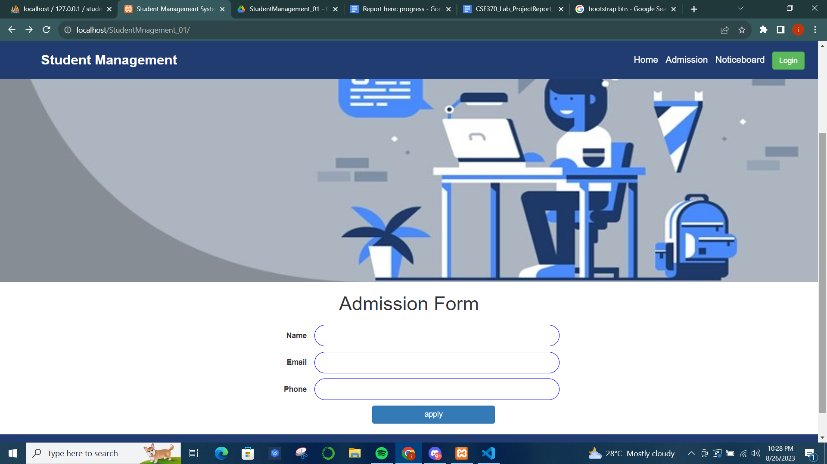

**Noticeboard:** The noticeboard page has a button Home in the nav bar, styled with Bootstrap btn that takes back to the homepage. The notice table was styled with the desired color, padding, height, and width using HTML and CSS wherever required.

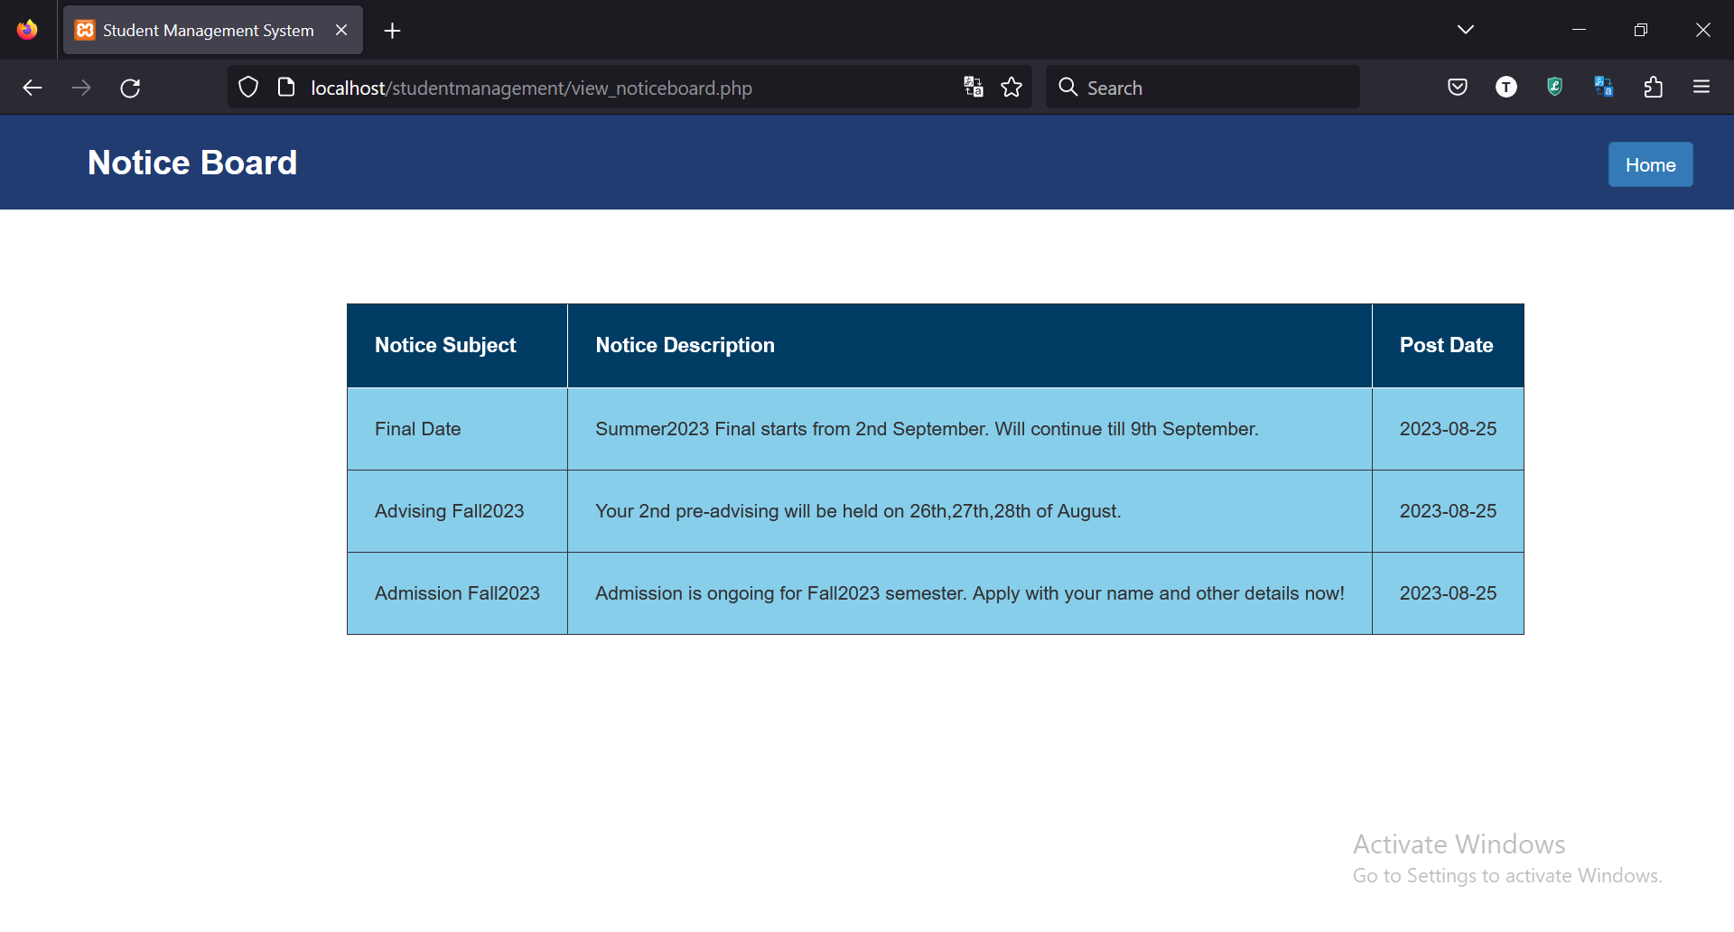

**Login Form:** The homepage login button navigates to the Login Form page which takes username and password as input and has a button for logging in. The style.css file includes the login page design, where margin, padding, color, font size, height, width, text decorations, and everything needed was assigned.

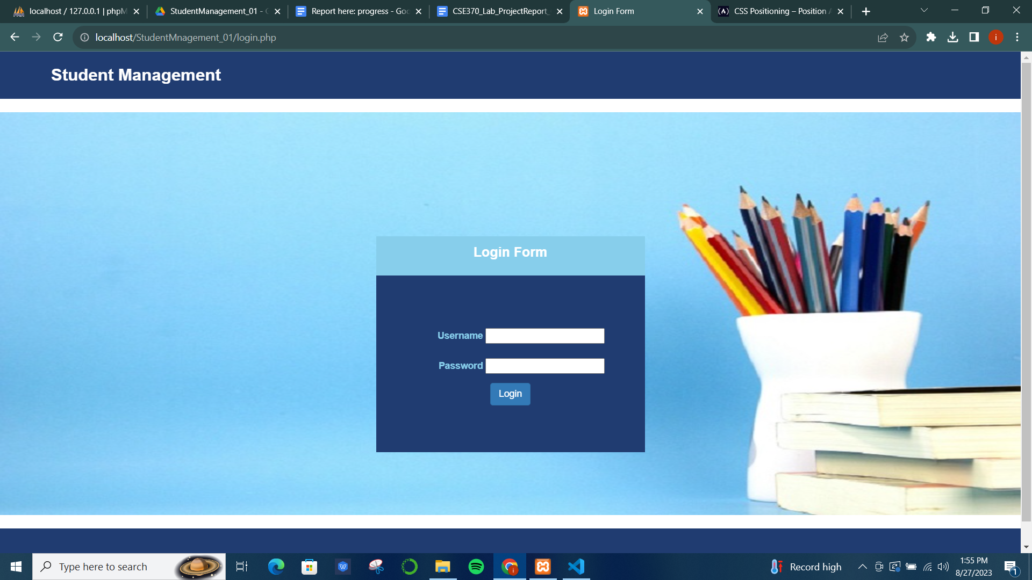

**Admin Dashboard:** The Admin dashboard was also designed using HTML, CSS, JavaScript, and Bootstrap. The Admin Dashboard has a navigation bar containing a title and a logout button. It also includes a sidebar that contains a list of options, each with a different hyperlink. Each option takes to a new page while the initial admin dashboard nav bar and sidebar design remain the same. The admin.css stylesheet contains all the design elements. For example:

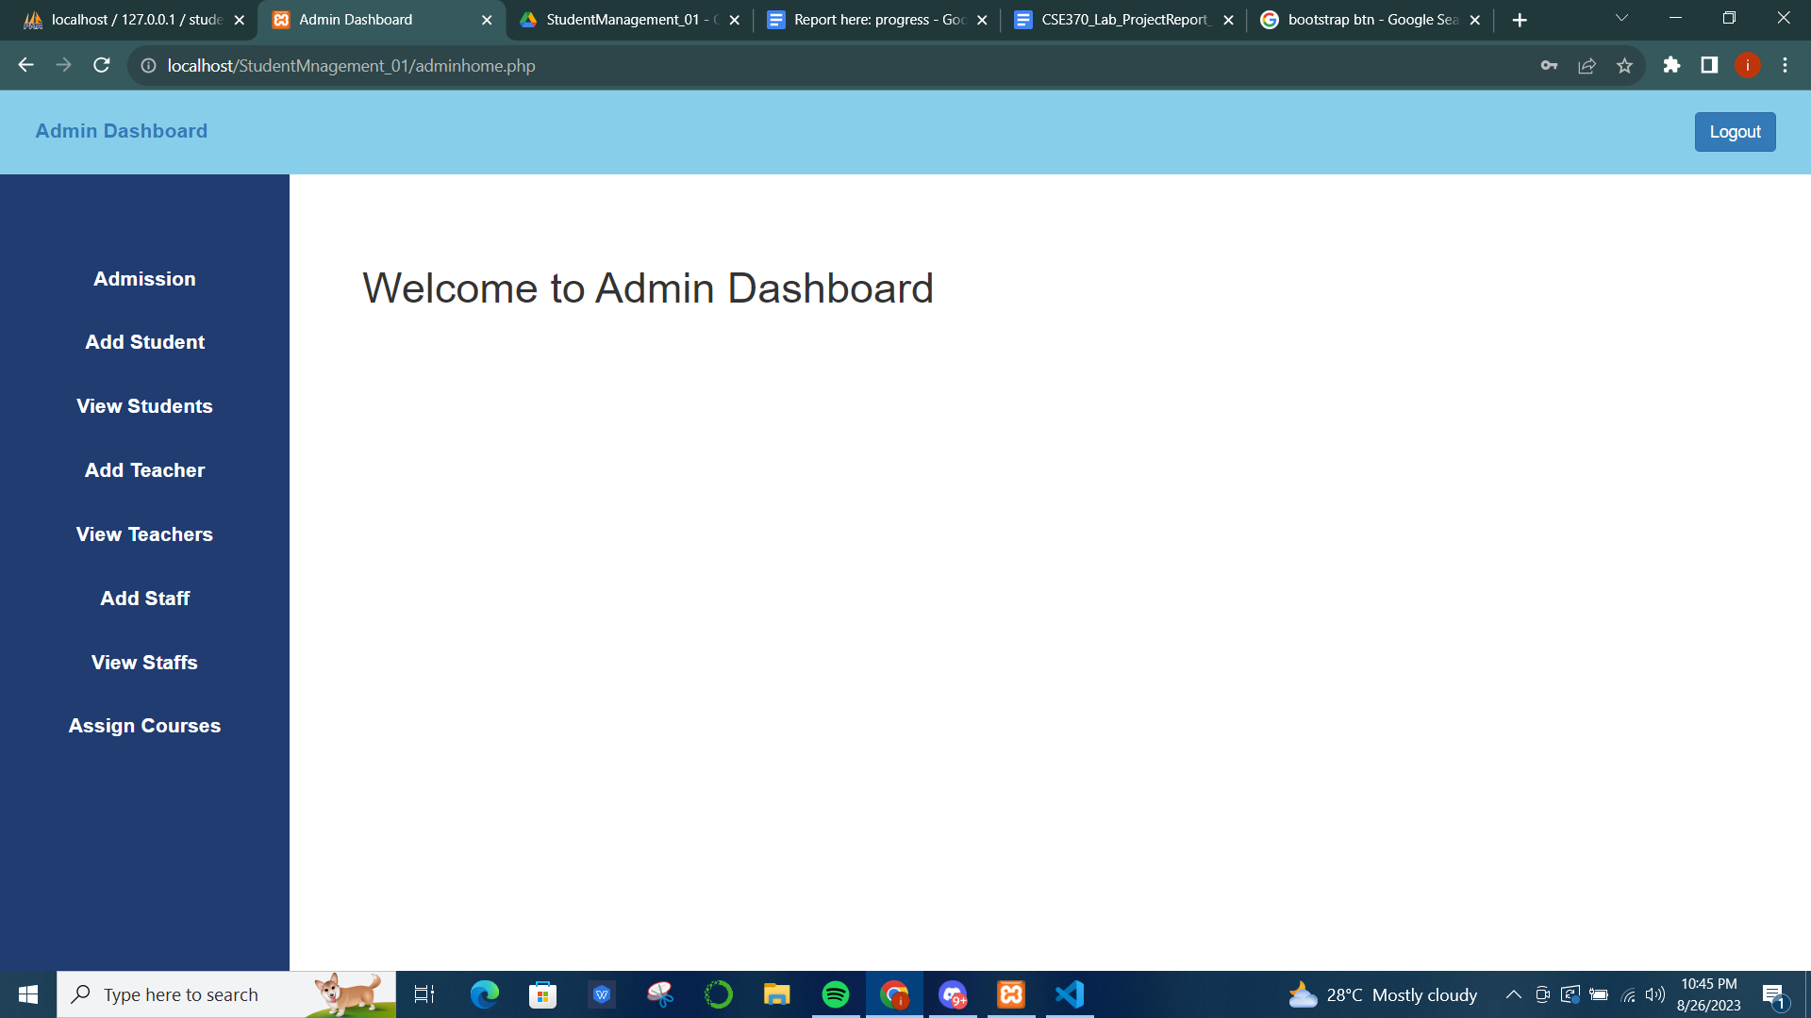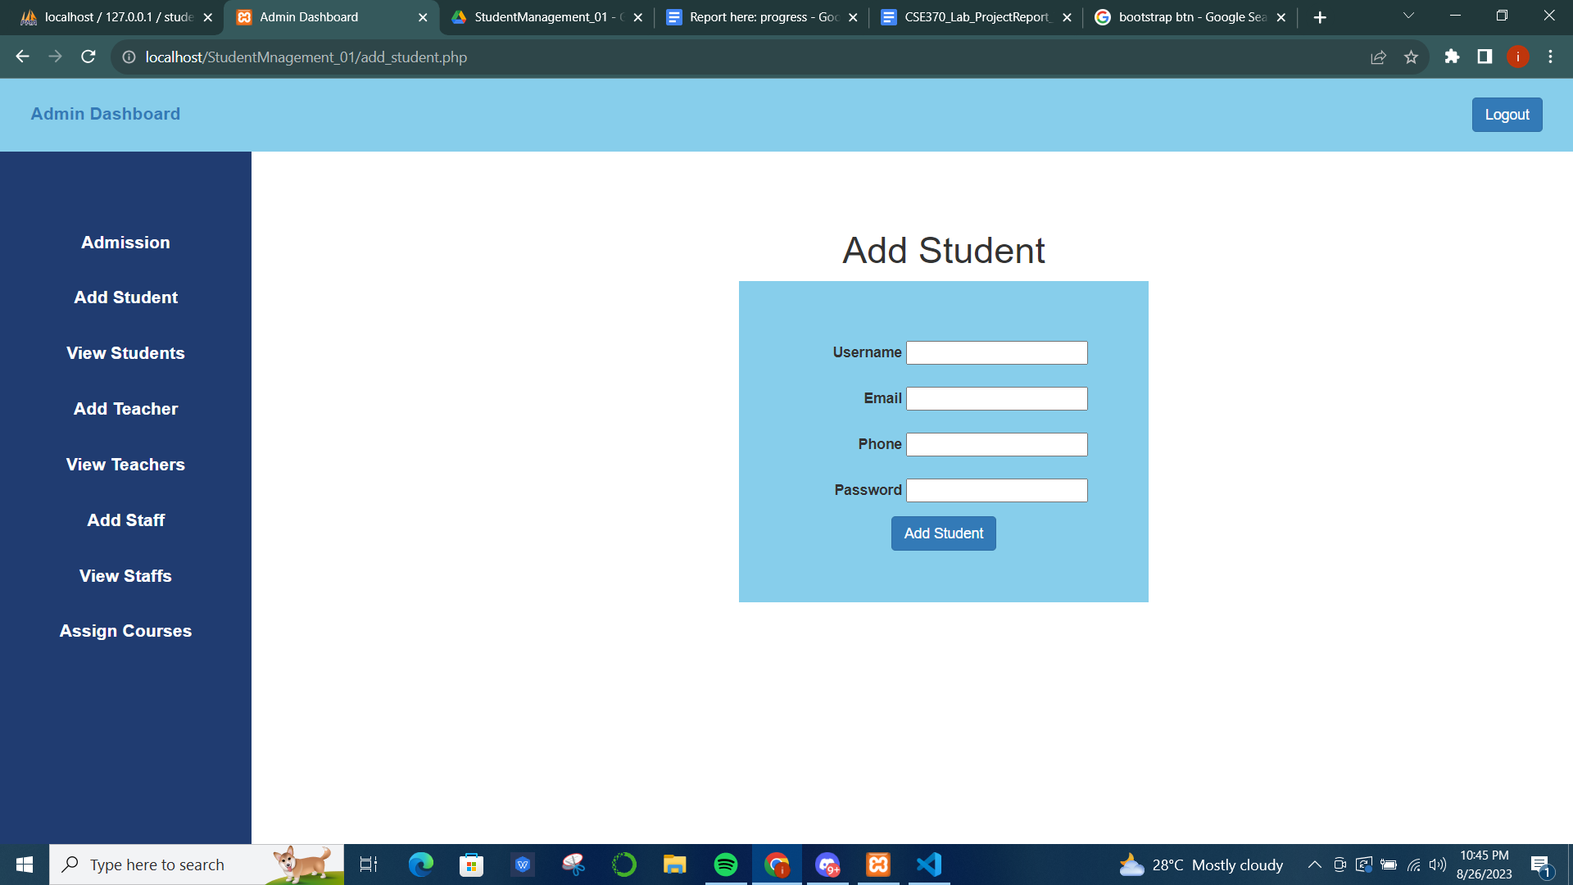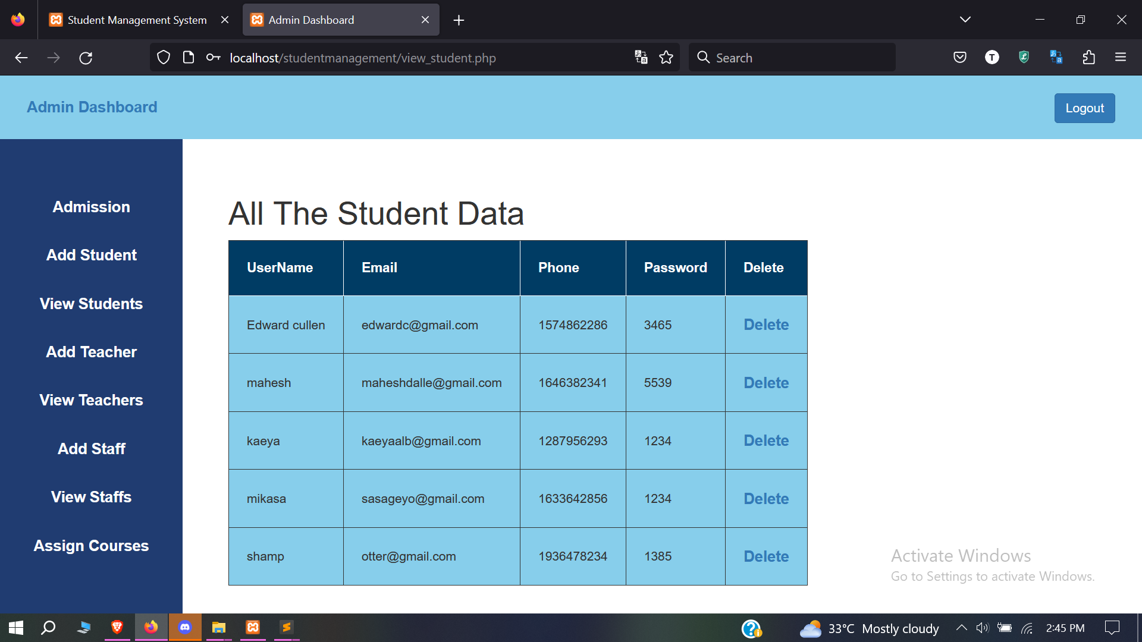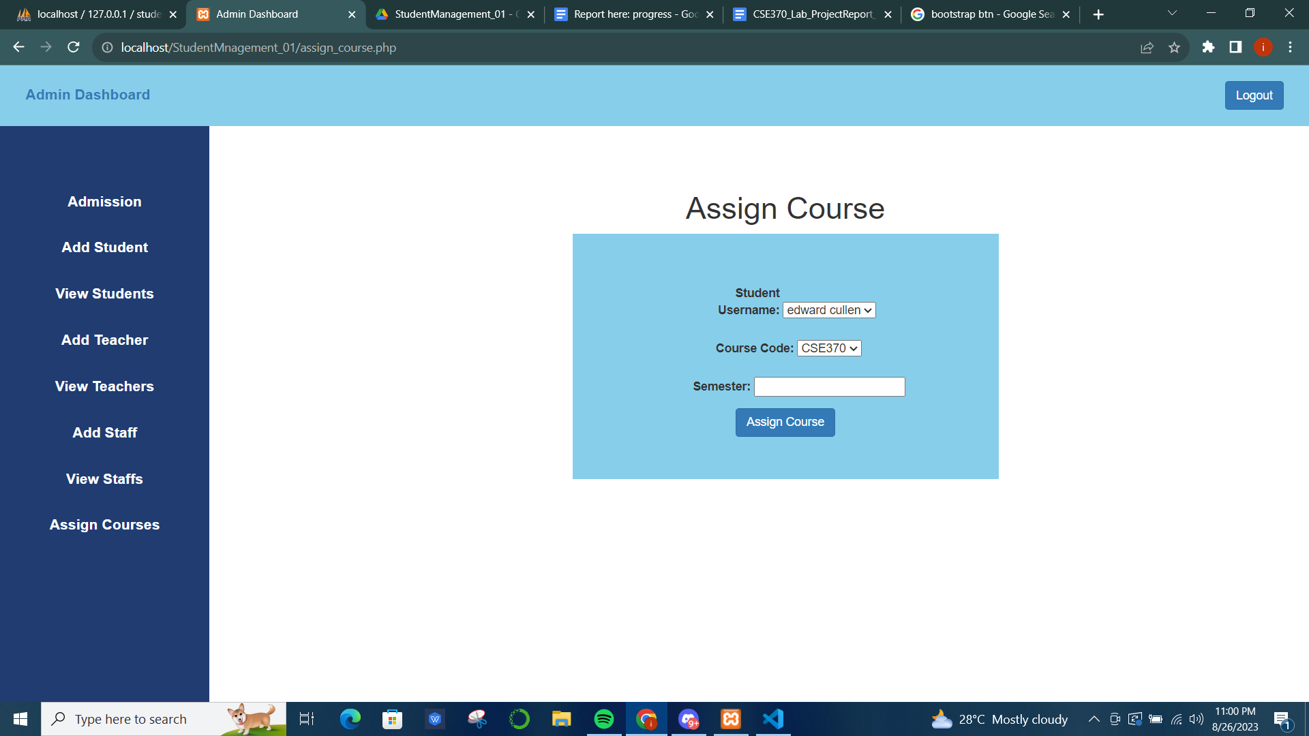

**Student Dashboard:** HTML, CSS, JavaScript, and Bootstrap were also used for frontend development in the Student Dashboard.

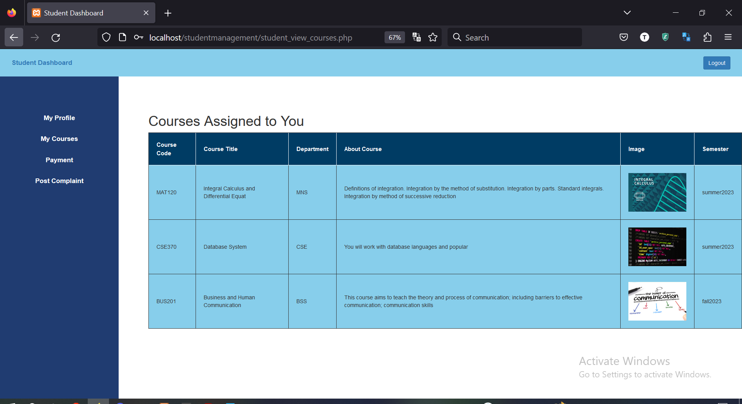

**Teacher Dashboard:** The teacher dashboard also has a similar design to the other users. Only the sidebar contains some different href choices.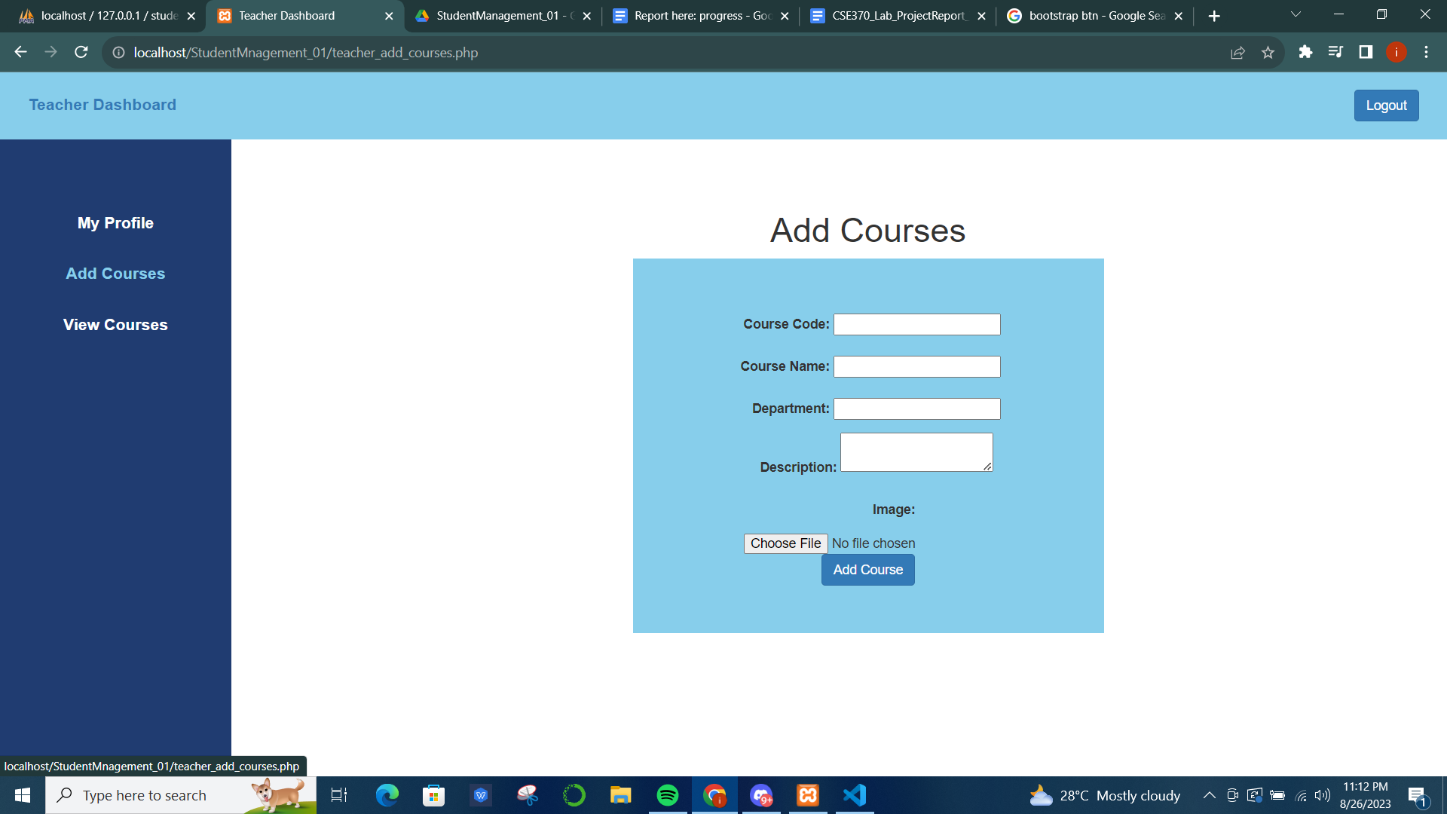

**Staff Dashboard:** The staff dashboard has some different options in the sidebar. Some designs are implemented using the same admin.css stylesheet and other style elements were added using CSS styling declarations inside cell tags.

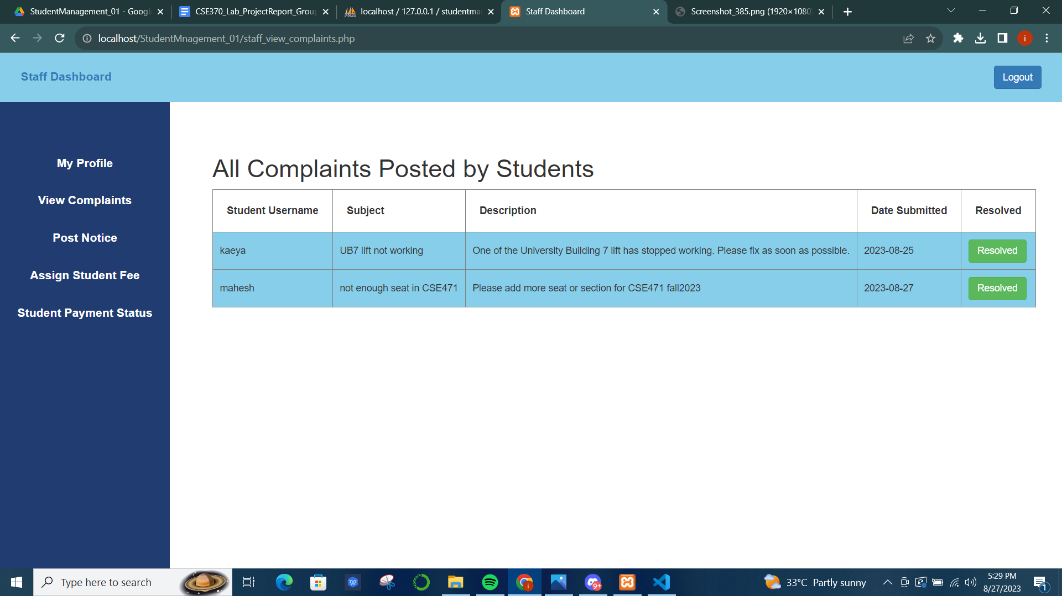

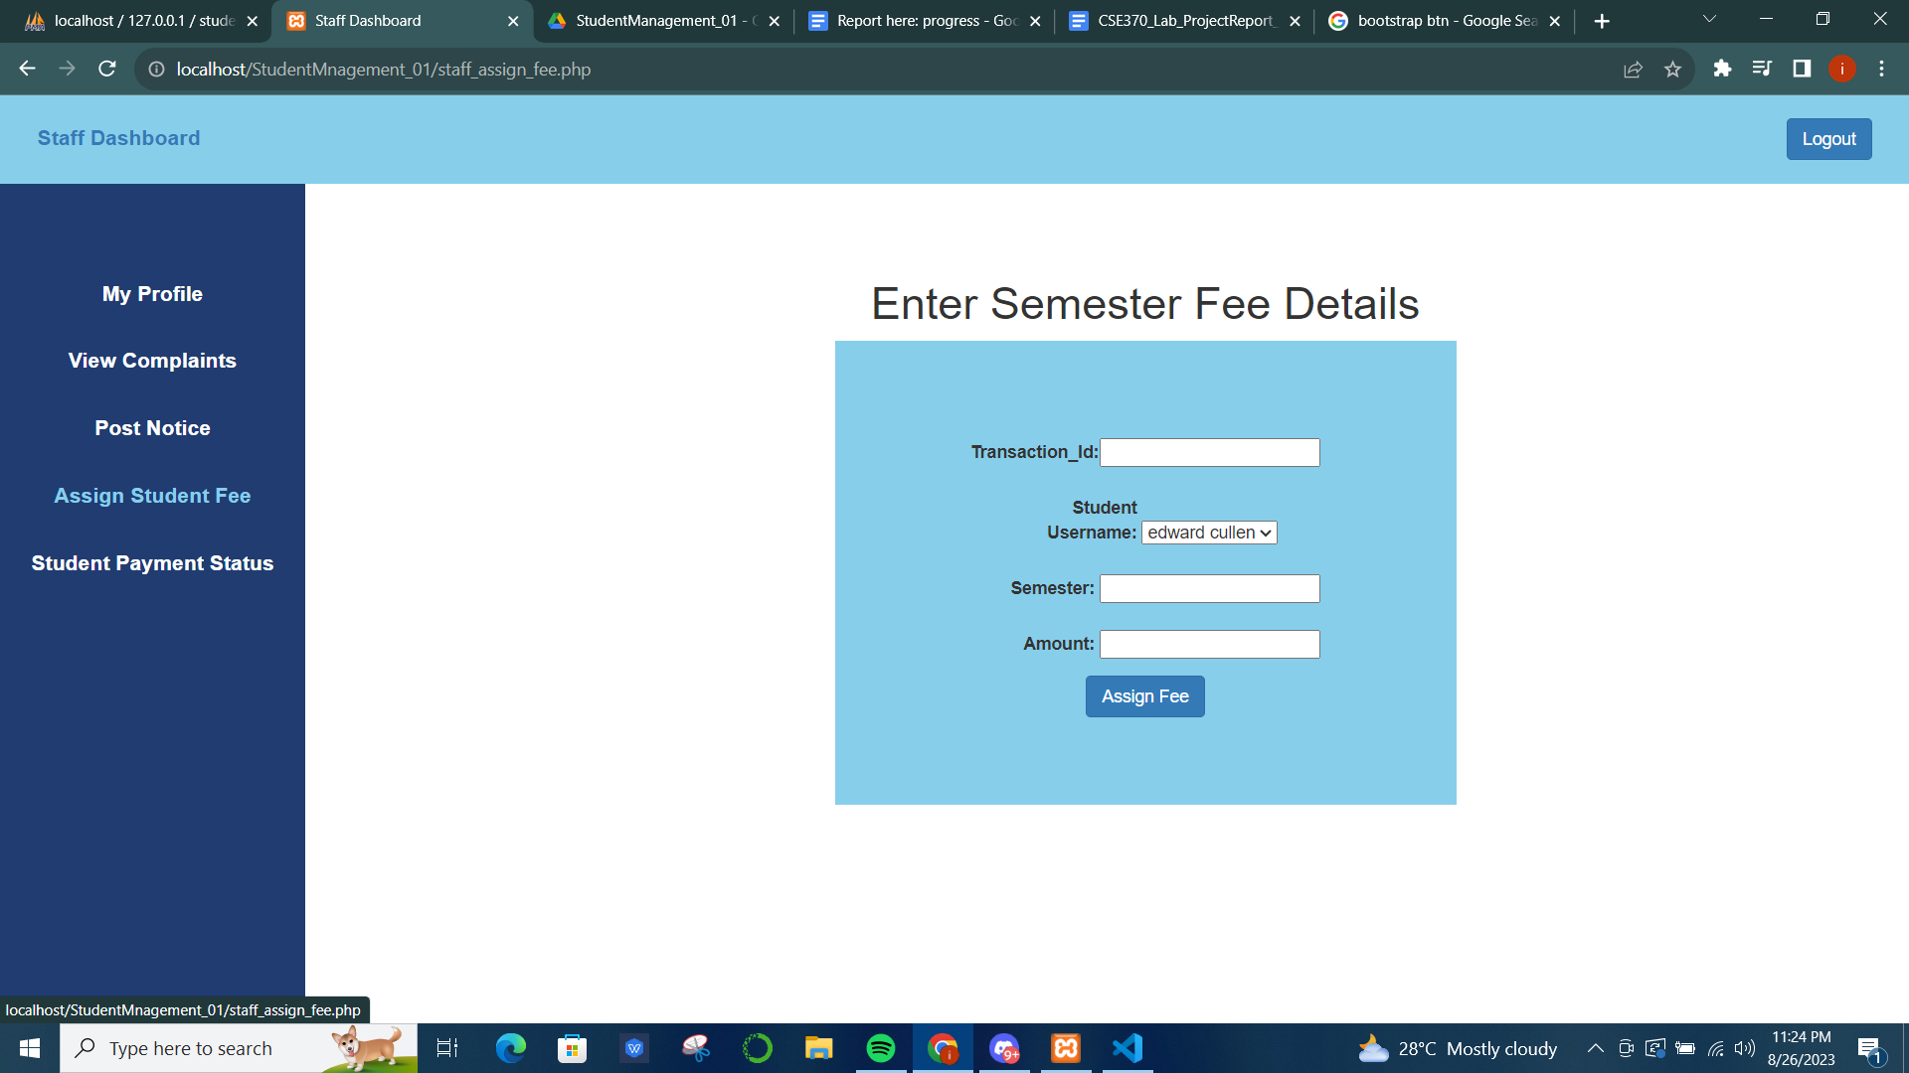

Lastly, all the necessary CSS, jQuery, and Javascript libraries metadata resources were linked to the system inside the HTML tag in every file.

**Contribution of ID: 20101021, Name: Ms Rodsy Tahmid**

The below screen is visible once ‘ View Student’ is clicked from the admin’s profile. This is achieved by implementing CSS for design, HTML for table, JavaScript for dynamic user interaction, and Bootstrap for specified color buttons like red delete buttons, and blue update buttons.

By clicking on ‘View Student’ from the sidebar from Admin Profile:

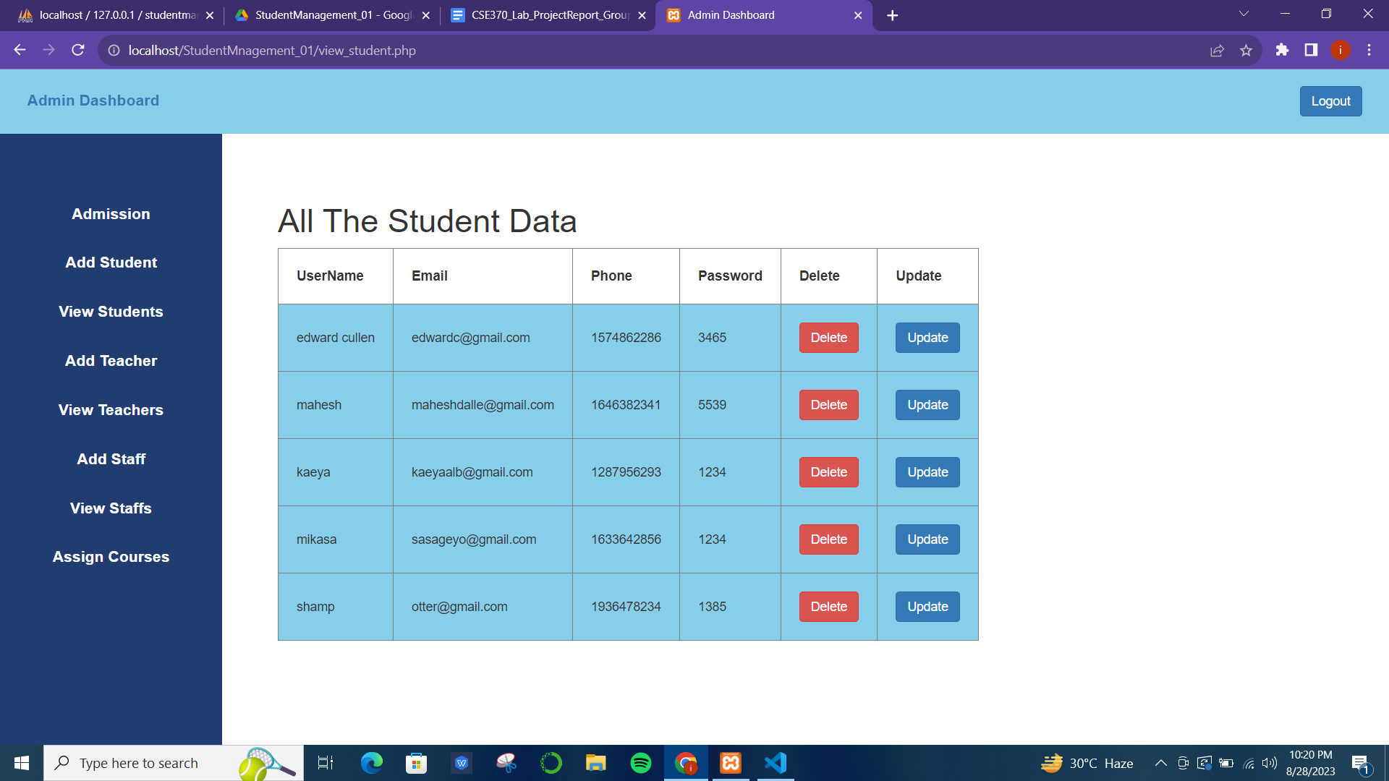

The view teacher and view staff page has a similar design to the add student page, where there is a delete button designed with the Bootstrap btn function.

By clicking on ‘View Teacher’ from the sidebar:

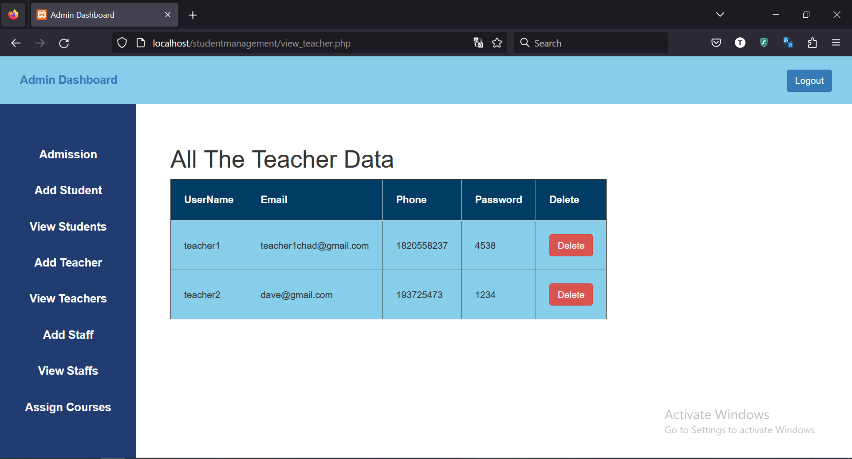

By clicking on ‘View Staffs’ from the sidebar:

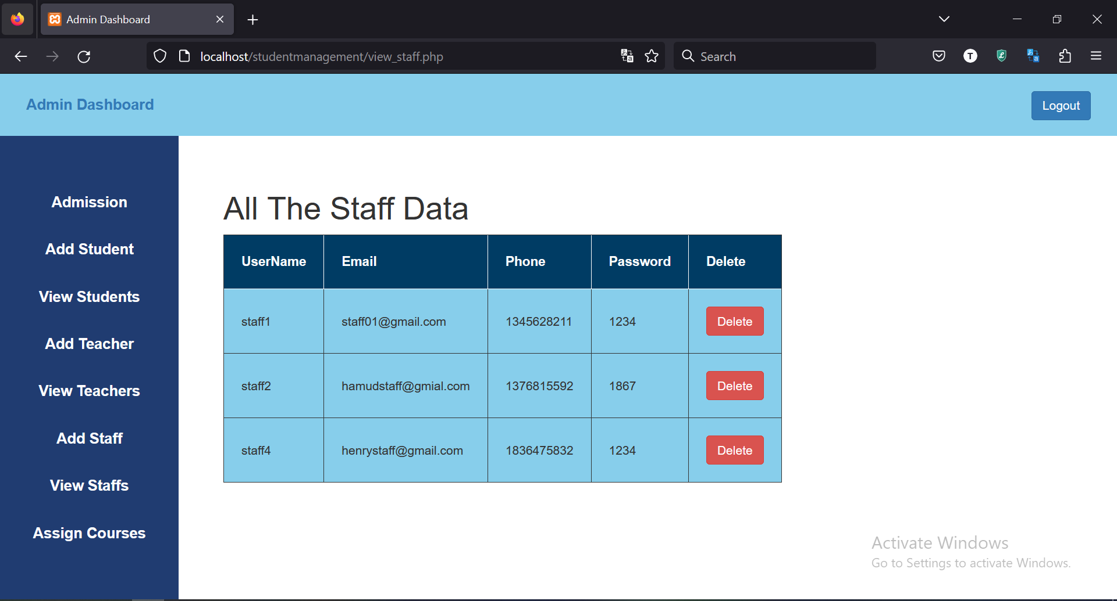

From the student’s profile, when the user clicks on ‘My Profile’, an update form page will appear as shown below which was also designed using HTML, CSS, and Javascript. The same is true for the teacher’s profile and the staff’s profile.

By clicking on ‘My Profile’ from the sidebar from Student Profile:

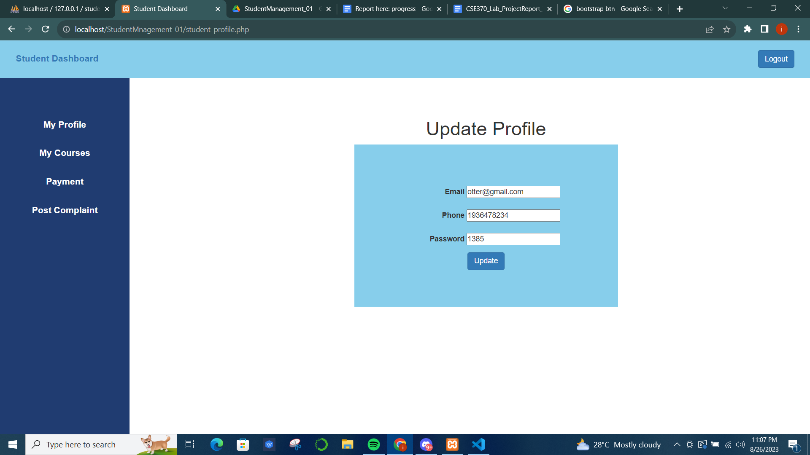

By clicking on ‘My Profile’ from the sidebar from Teacher Profile:

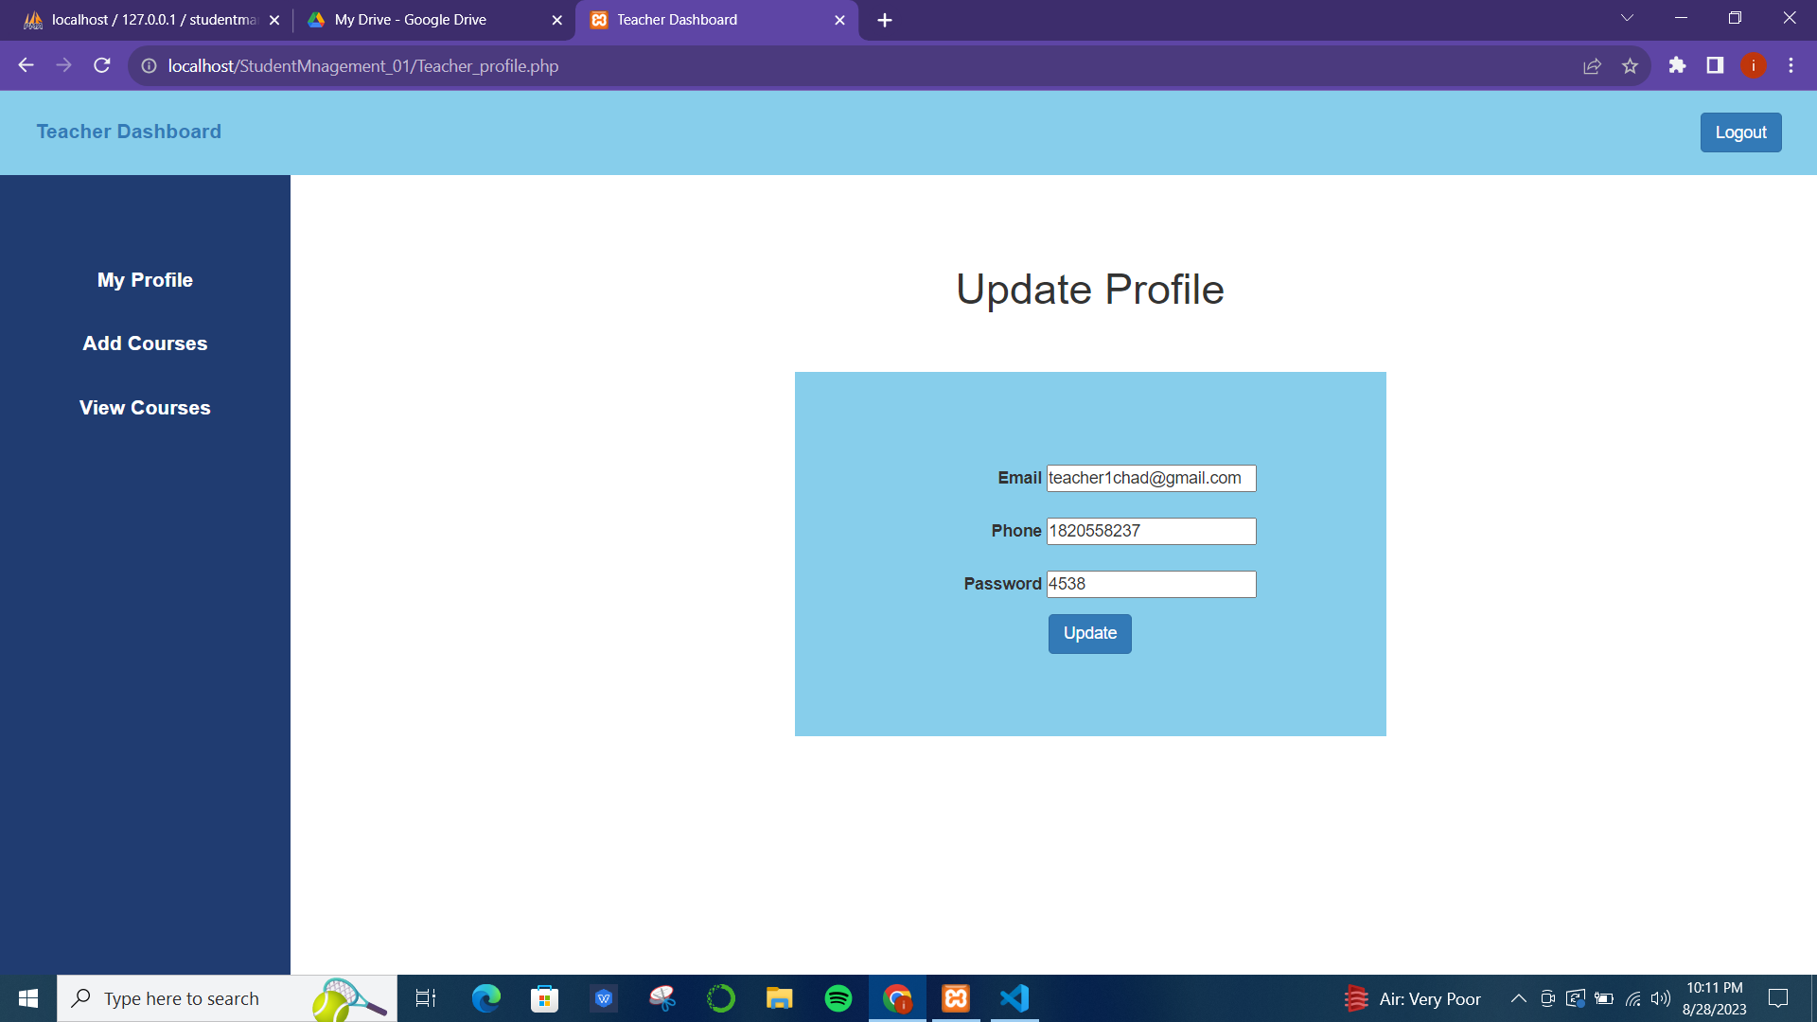

By clicking on ‘My Profile’ from the sidebar from Staff Profile:

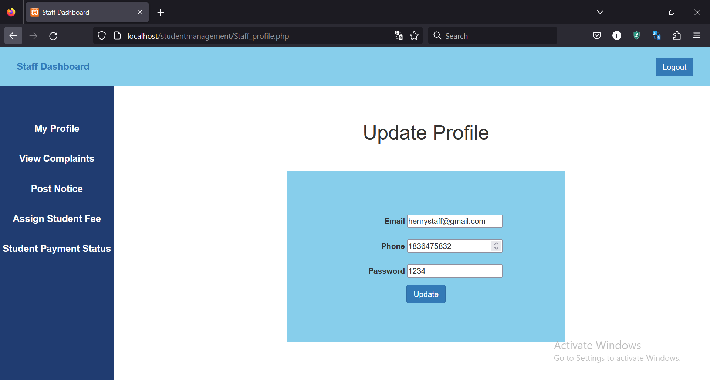

**Backend Development**

**Contribution of ID: 20101618, Name: Israt Jahan Ayshi**

For the backend development, PHP and SQL were used to connect to and interact with the database ‘studentmanagement’. Every time a form is submitted successfully a pop-up confirmation script will be echoed. For example:

**1. User Login System:** The homepage login button will take the user to the login form page. Here, users can log in with their unique username and password. On the login request method, the system will select the user from the ‘user’ table in the database using PHP and SQL commands where the username matches and send them to their respective dashboards based on the user type, such as admin, student, staff or teacher.

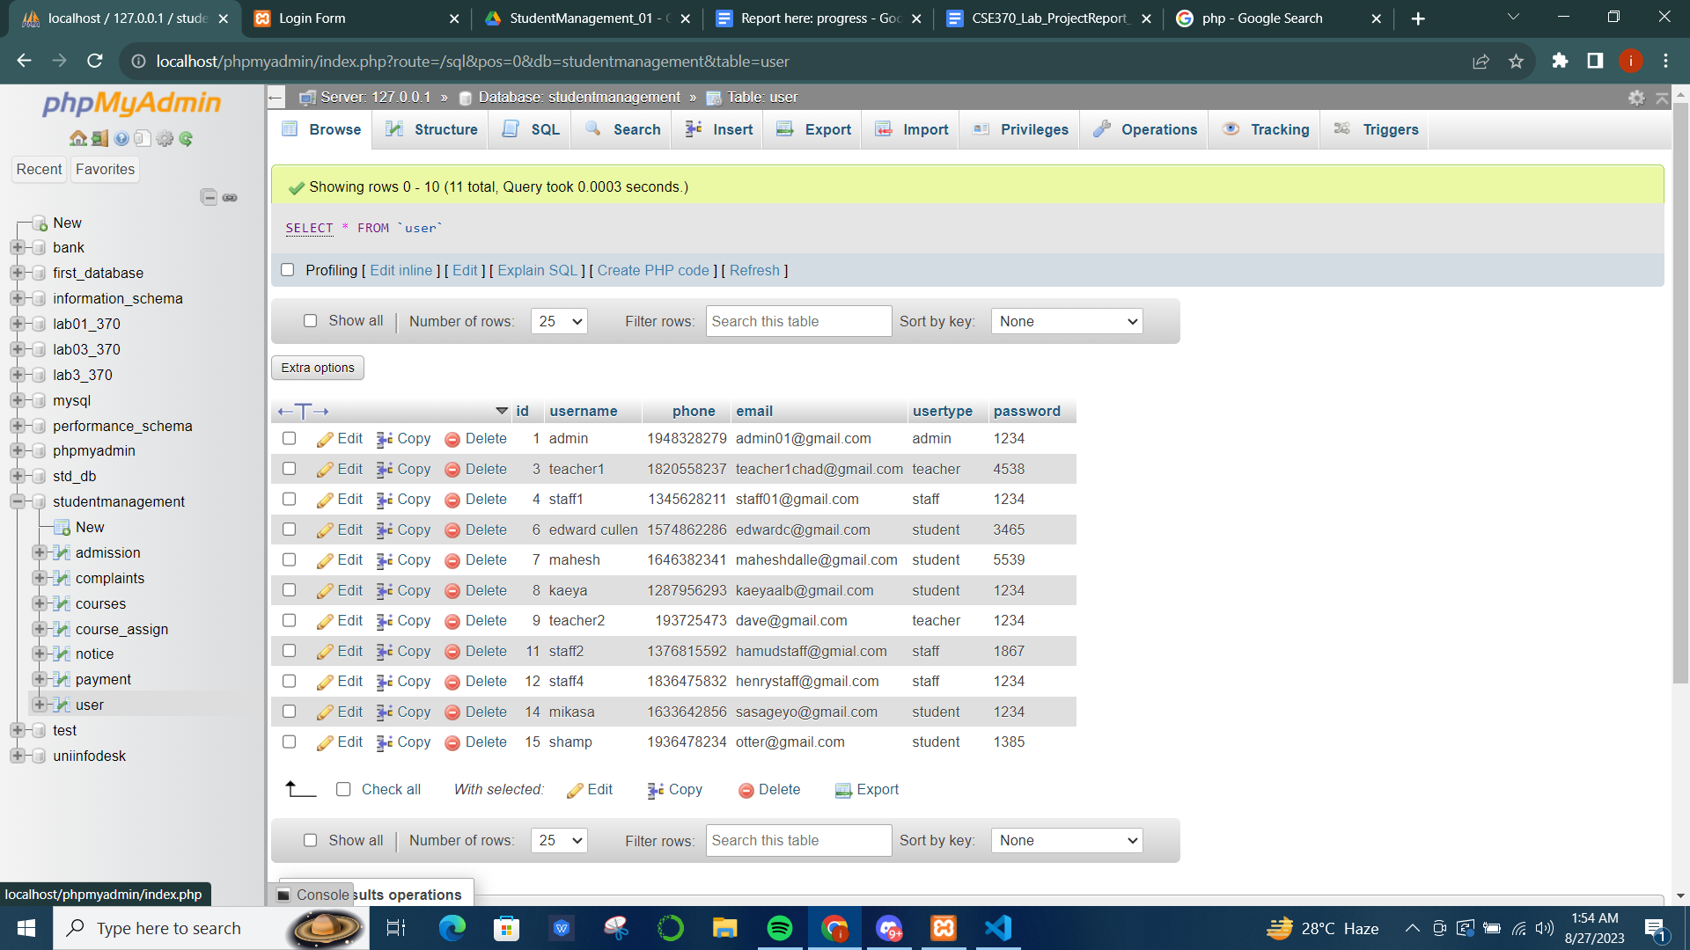

**2. Admission:** The admission form on the homepage takes inputs and stores them in the ‘admission’ table in the database. SQL insert command inside the PHP tag was used to store these input values.

**3.** **Admin Dashboard:** After logging in as admin the admin can see all the admission applicants’ information in a table which was implemented using SQL select all command to fetch rows from the admission table. Admin can also add students, teachers, and staff to the database. This was implemented inside a PHP tag using the SQL insert command to store user information in the user table. Admin can also view all these user information using the view options. This particular task was implemented using SQL select, to fetch and show them inside a table. Additionally, the admin can assign existing courses in the database course table to existing students. Here, the dropdown shows the courses and students for the admin to choose from. The select and insert commands were used to implement this function. Lastly, before each task, the system will check if the session usertype is set to admin or not using session variables inside PHP tag.

**4. Student Dashboard:** After login, the students can update their profile. Furthermore, by clicking the ‘My Courses’ option the students will be able to view the courses they were assigned to by the admin. In this case, SQL select and join commands were used to connect the ‘course_assign’ and ‘courses’ table and then show only the information from the ‘courses’ table of the courses that particular student was assigned to. Students can also view if they were assigned transaction ID and payment details for their semester fee and choose to pay the fee. By clicking the pay fee button with each transaction ID row the user will be able to see a form where they can put their account details and make payment. By doing this the account info will be stored in the ‘payment’ table in the database and the already set unpaid payment status will be set to paid automatically. Students can also post complaints using a form that will be saved in the ‘complaints’ table inside our database.

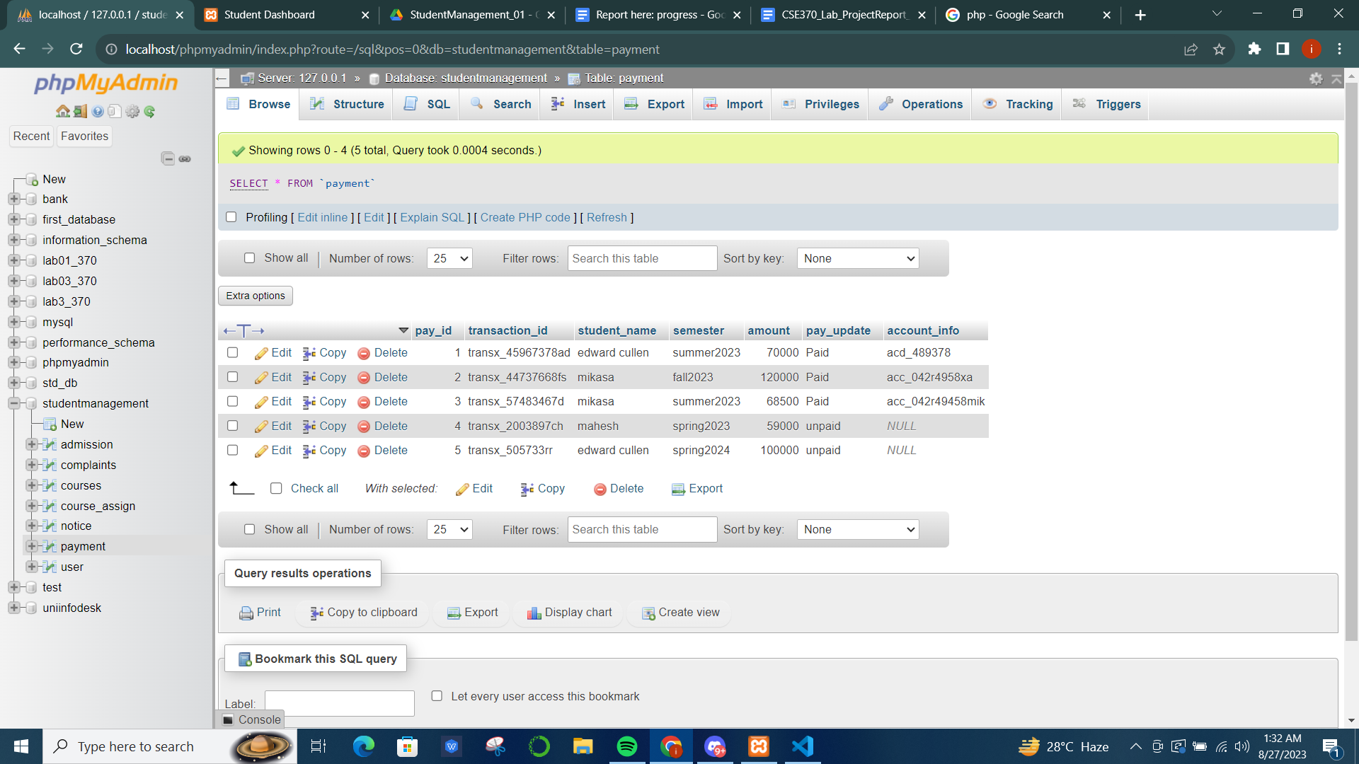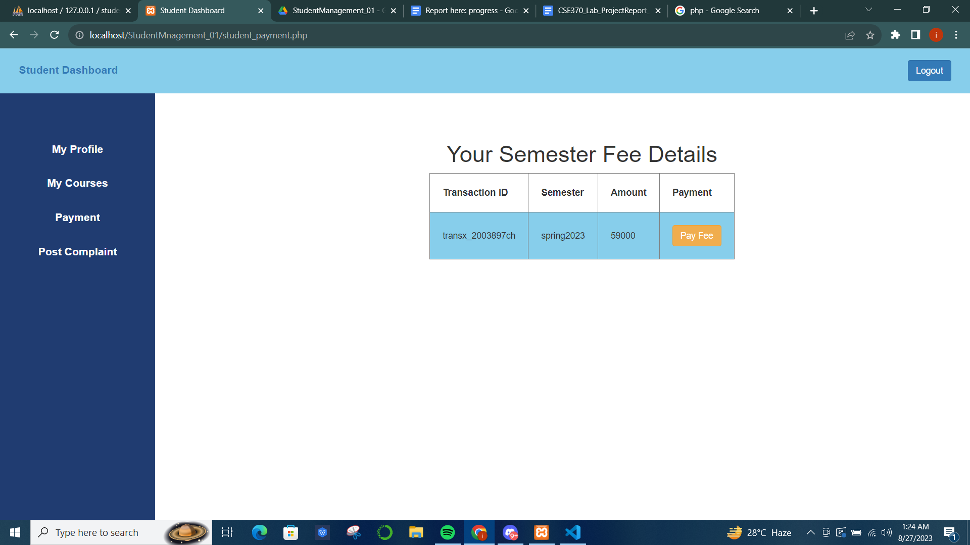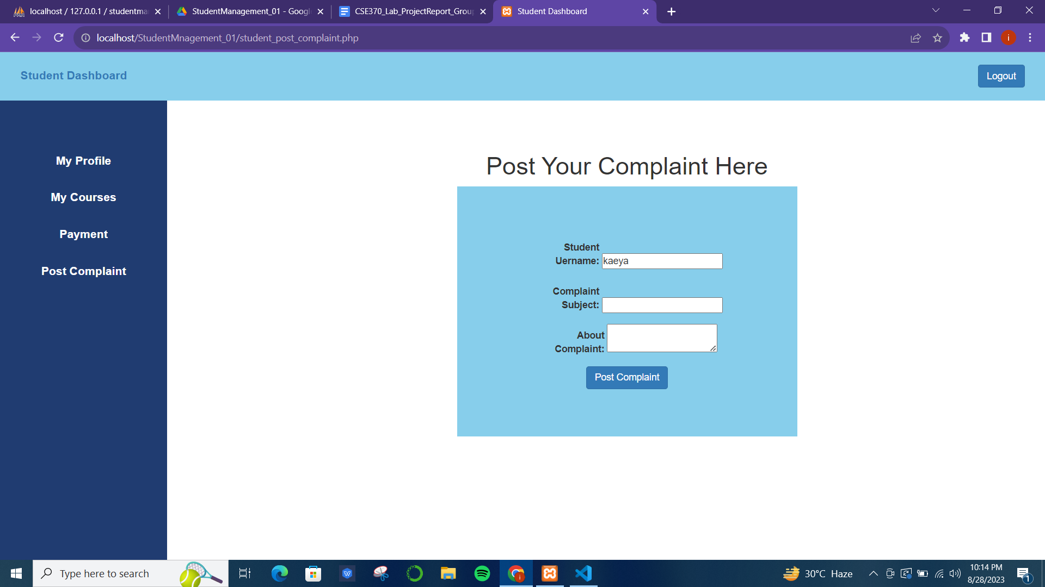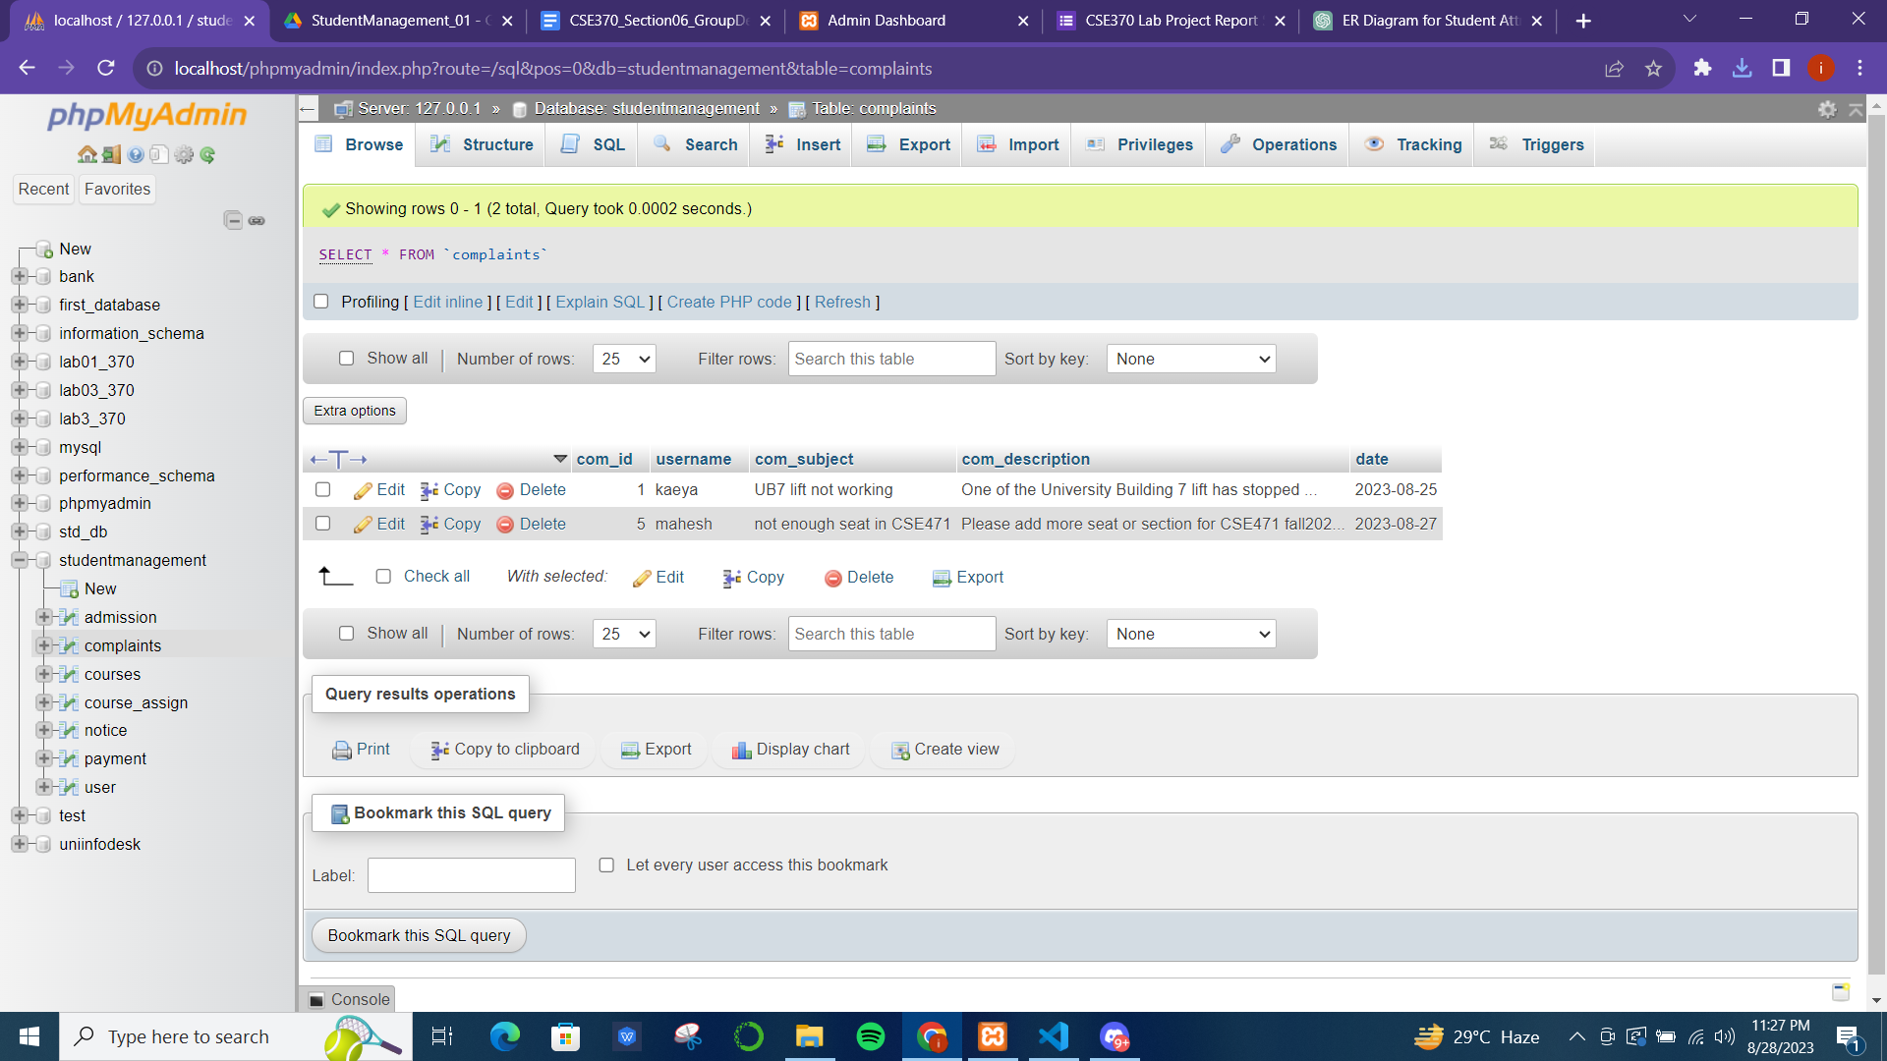

**5. Teacher Dashboard:** After logging in to the teacher dashboard they can add courses by inserting a unique course code, name, department, description, and an image for the course. One course code can be added only once and this was implemented by checking if the row count for a course code is >=1 or not. Once the ‘add course’ button is clicked the information will be saved in the database using SQL insert command. Moreover, a teacher can also view all the course details added to the database.

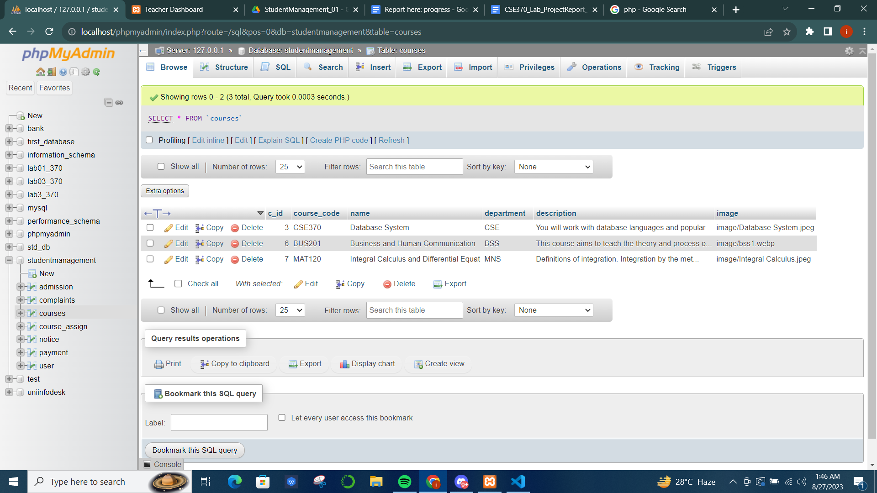

**6. Staff Dashboard:** Staff members can view all the complaints posted by the students and push the resolved button once the concern is resolved, which will remove that complaint from the database. SQL select was used to show complaint details while the delete command was used to remove resolved complaint IDs from the database. Furthermore, staff members can post any notice using a form, these notices will be stored in the ‘notices’ table in database and appear on the noticeboard. Additionally, staff are tasked to assign payment details with unique transaction IDs to the students inside the database. Here they can choose from existing students using dropdown selection. This part brings out all the unique usernames of student usertype using select and mysqli query. The pay_update will be set to unpaid initially and account_info will be null inside the database. Other than these, the staff can also view the payment details of the students.

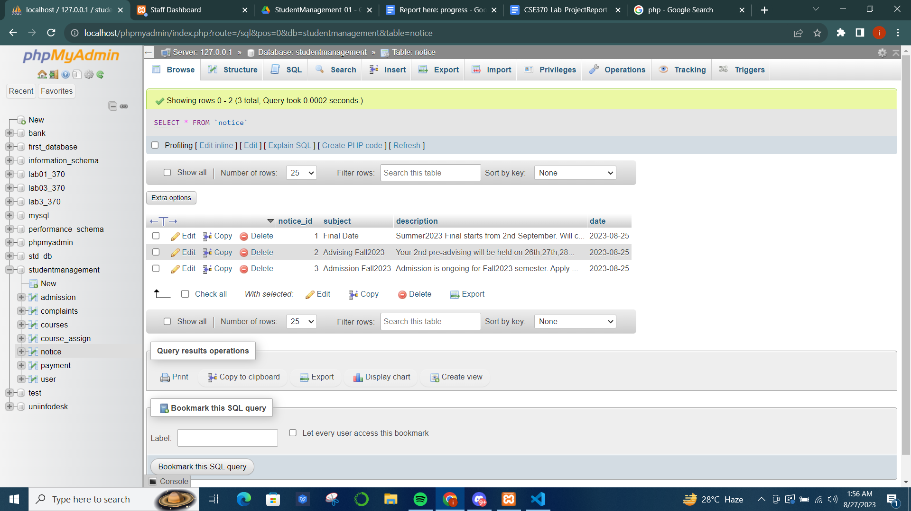

**Contribution of ID: 20101021, Name: Ms Rodsy Tahmid**

The admin can update and delete a particular student from the database by clicking on ‘View Students’ and a screen similar to the below picture will show. From there, he/she can delete any student they want by clicking on the ‘Delete’ button that is on the rightmost part of the table labeled ‘Delete’ column. Once they click ‘Delete’ of whichever student they want to remove, the entire row of that particular student will be deleted. The same is true for the ‘update’ function, here once the admin clicks on the ‘update’ button, it redirects it to the update student page which we’ve previously seen on the ‘Add Student’ sidebar.

By clicking on ‘View Student’ from the sidebar from Admin Profile:



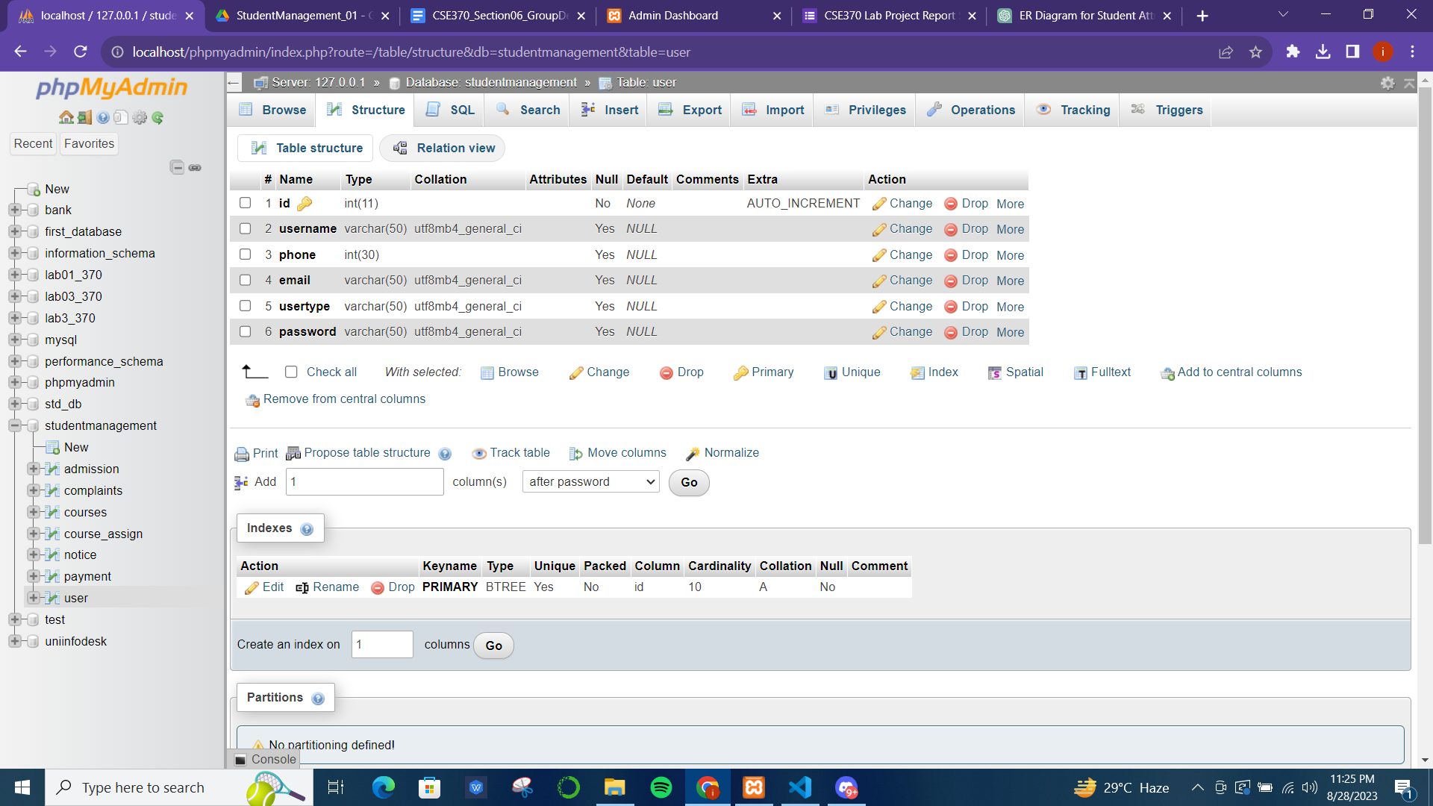

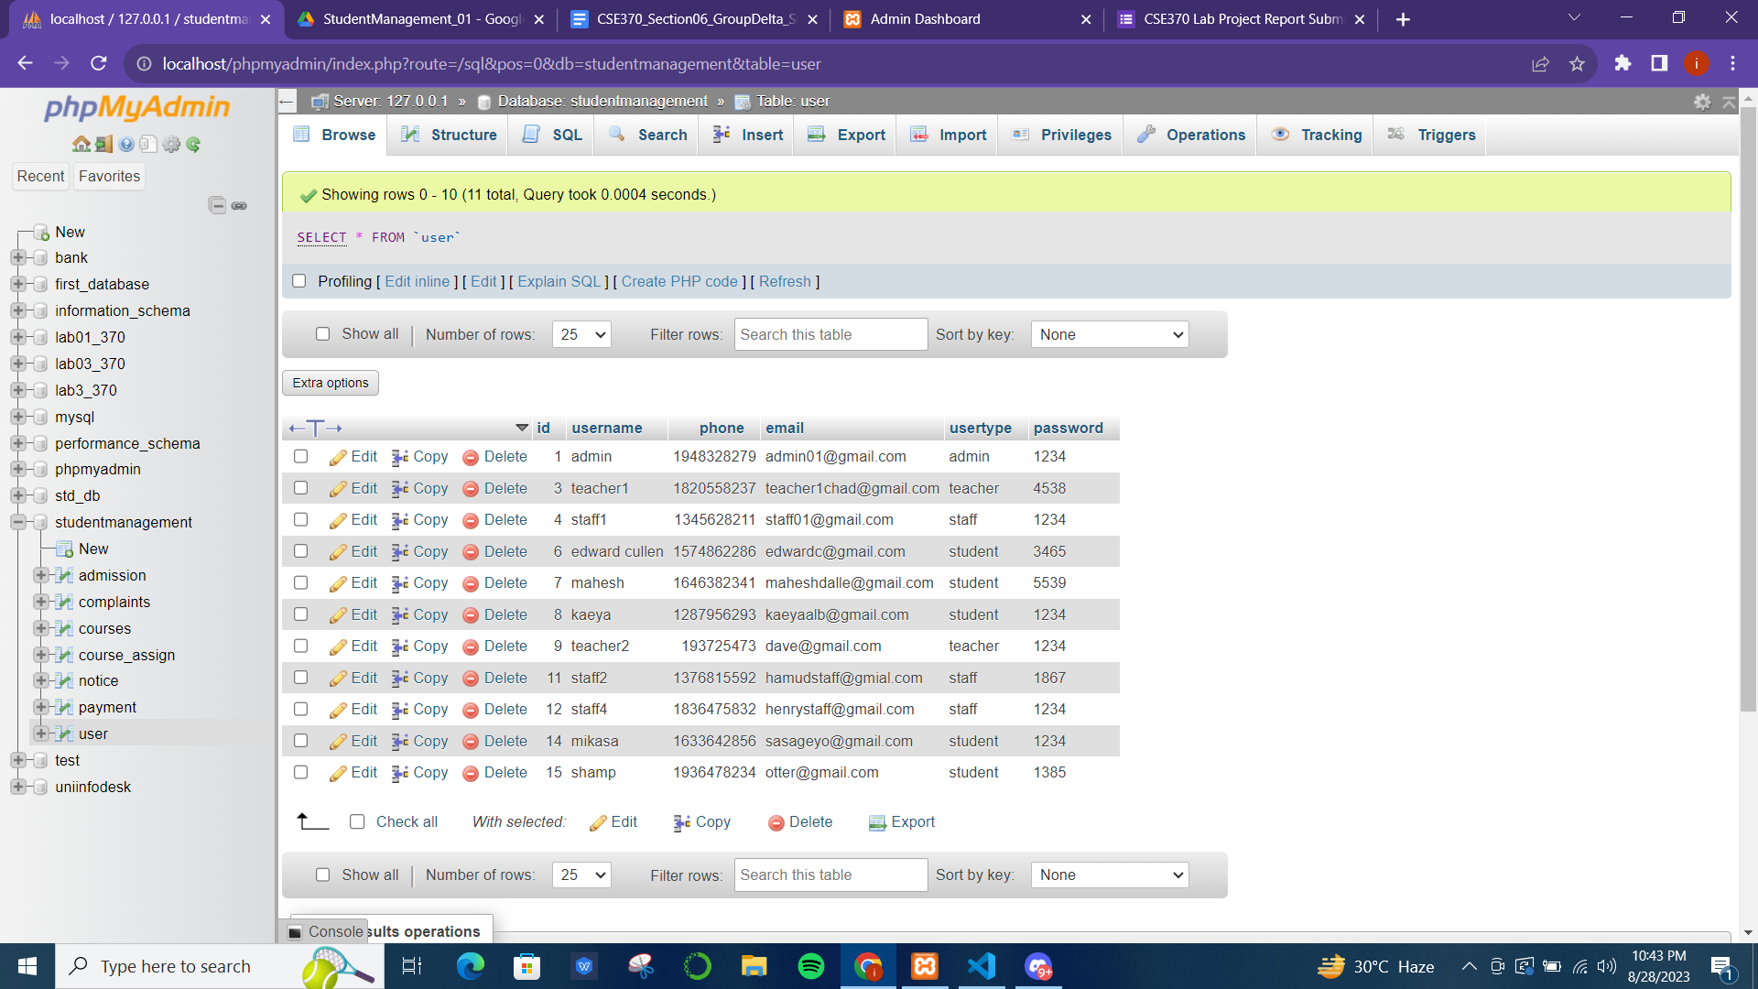

The same update, add, and delete options are available for both the teacher and the staff from the admin panel:

By clicking on ‘View Teachers’ from the sidebar from the admin profile:



By clicking on ‘View Staffs’ from the sidebar from the admin profile:



From the student’s profile, they can only change their own information like email, phone, or password. This can be done by clicking on the ‘My Profile’ option from the sidebar and the below screen will be shown where the student can update their own information. However, they cannot add or delete themselves or any other student.

By clicking on ‘My Profile’ from the sidebar from Student Profile:



Just like the student, a teacher member can change their own information but they cannot add or delete themselves. Neither can they add or delete any teacher or student like the admin.

By clicking on ‘My Profile’ from the sidebar from Teacher Profile:



Just like the student and teacher, a staff member can change their own information but they cannot add or delete themselves. Neither can they add or delete any teacher or student like the admin.

By clicking on ‘My Profile’ from the sidebar from Staff Profile:



**Contribution of ID: 20201027, Name: Sabikun Nahar**

* Student Complaints.
* Staff can view and resolve the complaints.
* Admin can only view the complaints, but not resolve them.

1. **Student Complaints Dashboard:**A student can create a complaint regarding any subject. For that, the student has to go to the “Complaints” page, and then automatically his/her username and phone number will be displayed. The student has to fill up the “Subject” part of the complaint and then fill up the “Complaint” part with his/her actual complaint. Then it will be submitted and will be stored in the “complain” table of the database.

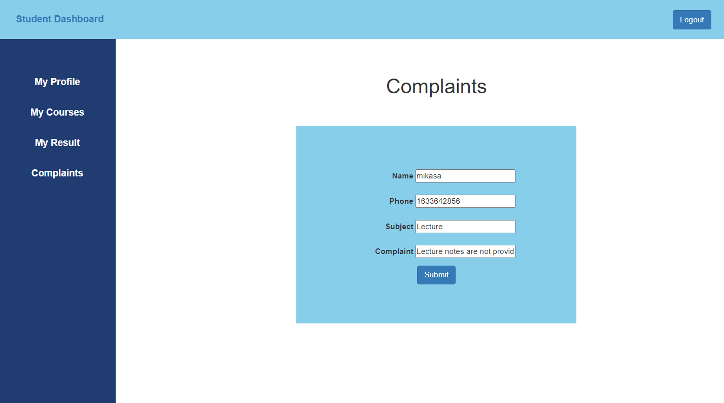

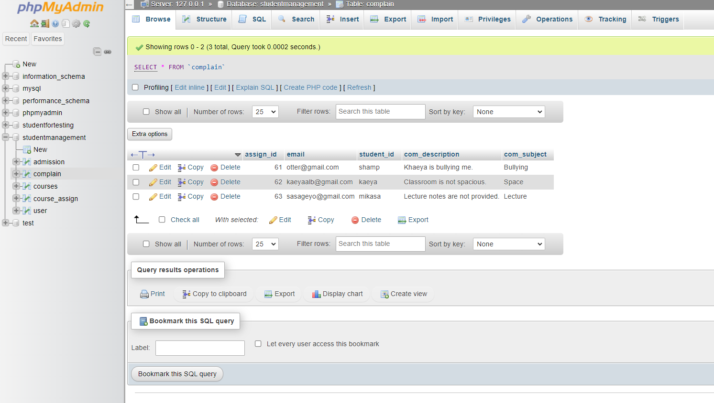

1. **View Complaints Part for Staff:**Here, staff can see and resolve all the complaints made by the students. If the staff has resolved the complaint, clicking the “Resolve” button will remove the complaint of the student from the complaint table of the database. The staff has full authority over resolving and fixing the complaints of the students.

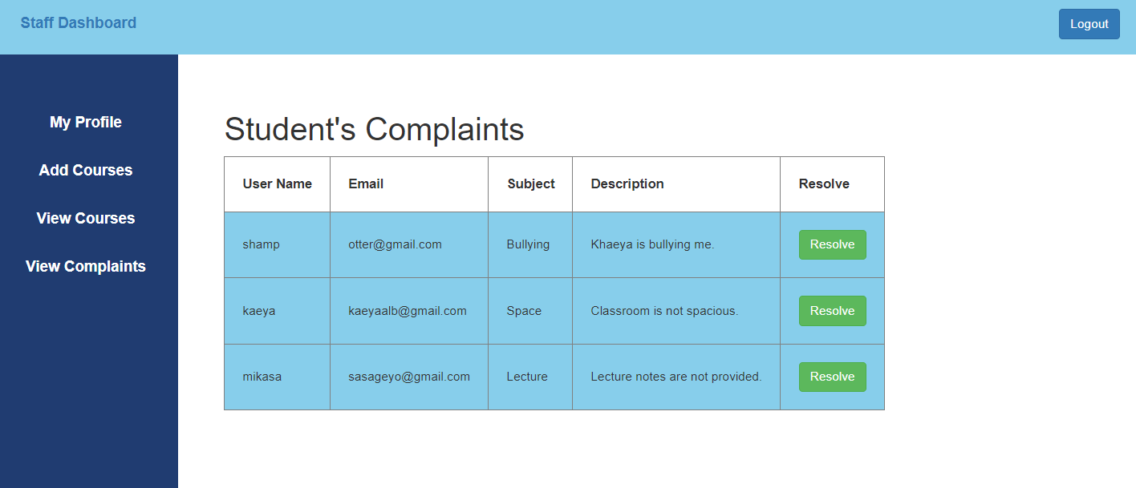

1. **View Complaints Part for Admin:**An admin can only view the complaints made by the students. However, he can not resolve or remove the complaints from the actual “complain” table of the database. The authority for resolving the complaints goes to the staff.

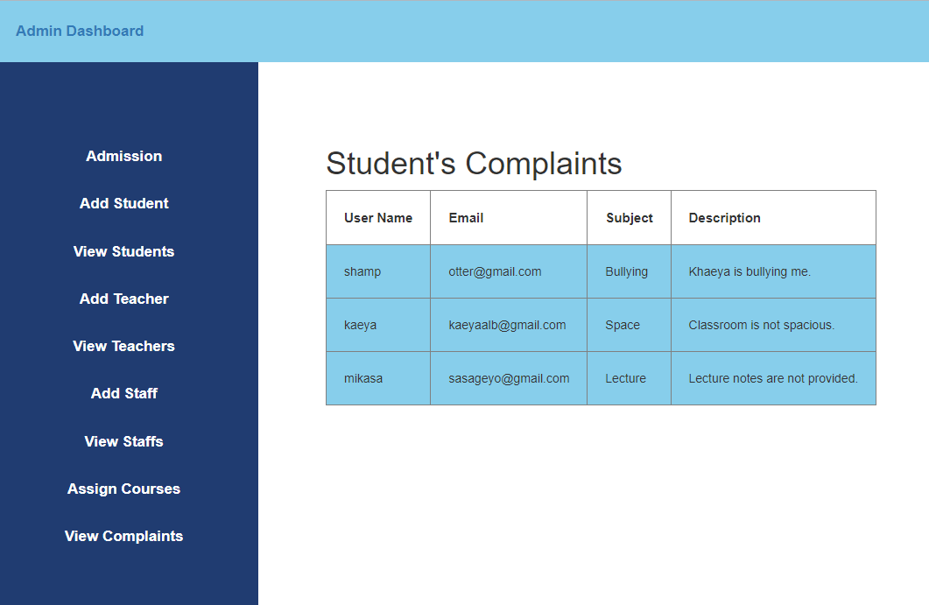

**Conclusion**

The Student Management System project successfully integrates SQL, Bootstrap, PHP, and JavaScript to create a comprehensive platform for streamlined student administration. With user-specific dashboards, the system handles tasks ranging from profile updates to payment processing and complaint submissions. Frontend development yielded visually appealing interfaces, while the backend, driven by PHP and SQL, facilitated efficient data management. Notably, the system's approach to addressing student complaints promotes transparency and quick resolution. Overall, this project exemplifies how collaboration between frontend and backend technologies can revolutionize educational administration, promising enhanced efficiency and user experiences.

**References**

1. W3school. <https://www.w3schools.com/bootstrap/bootstrap_get_started.asp>